**DAILY ONLINE ACTIVITIES SUMMARY**

|  |  |  |  |  |  |  |  |  |
| --- | --- | --- | --- | --- | --- | --- | --- | --- |
| **Date:** | **11-06-2020** | | | | | **Name:** | **SRILATHA K KAMATH** | |
| **Sem & Sec** | **6 B** | | | | | **USN:** | **4AL17CS099** | |
| **Online Test Summary** | | | | | | | | |
| **Subject** | | **Python Application Programming** | | | | | | |
| **Max. Marks** | | **20** | | **Score** | | | **18** | |
| **Certification Course Summary** | | | | | | | | |
| **Course** | **E box Online Classes** | | | | | | | |
| **Certificate Provider** | | | **Amphisoft** | | **Duration** | | | **1 ½ hours** |
| **Coding Challenges** | | | | | | | | |
| **Problem Statement:** Python Program to find the average of all Items in a Dictionary. Java program to find the nodes which are at the maximum distance in a Binary Tree. Python program that converts a string to all uppercase. | | | | | | | | |
| **Status: COMPLETED** | | | | | | | | |
| **Uploaded the report in Github** | | | | | **YES** | | | |
| **If yes Repository name** | | | | | https://github.com/alvas-education-foundation/Srilatha-K-Kamath-Daily-Report.git | | | |
| **Uploaded the report in slack** | | | | | **YES** | | | |

Online Test Details:

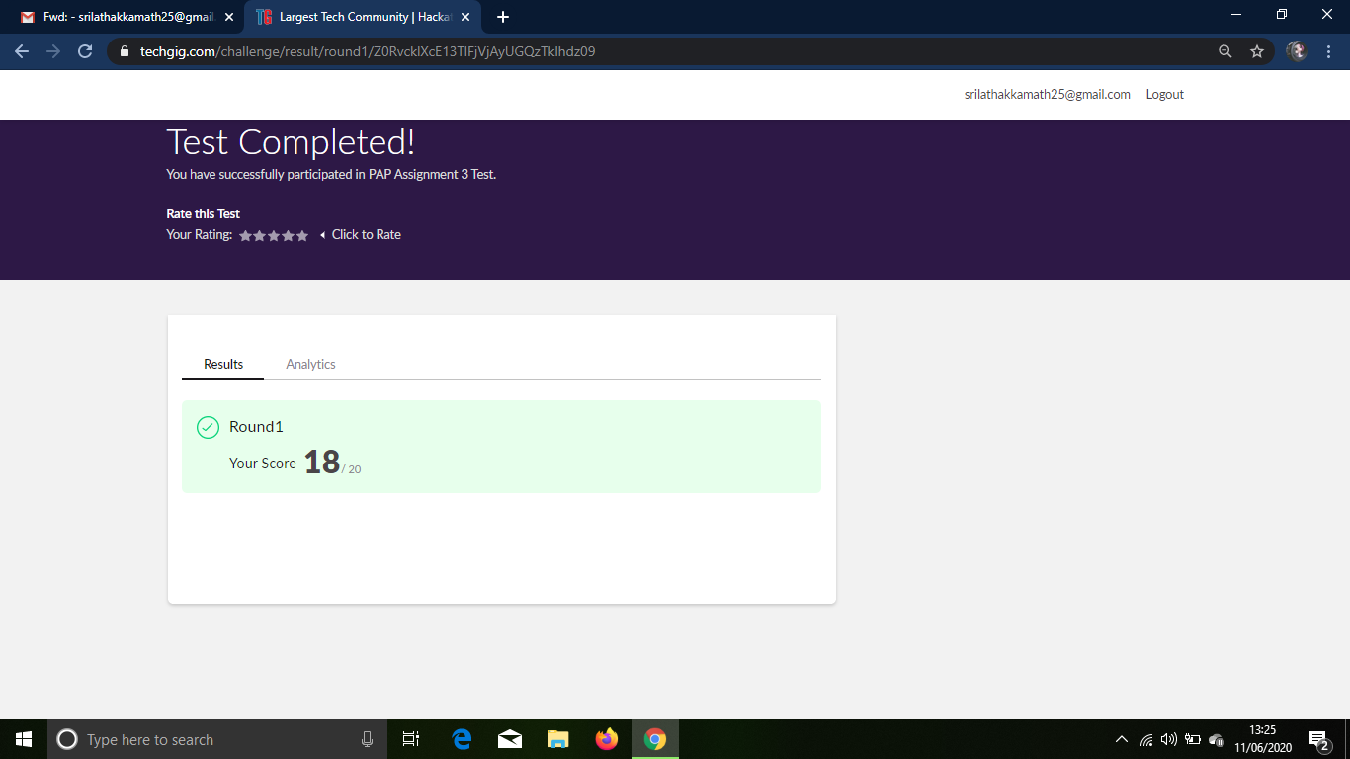

Online Course Details: Attended e-box zoom class on Java.

Topics taught: Types of Exceptions.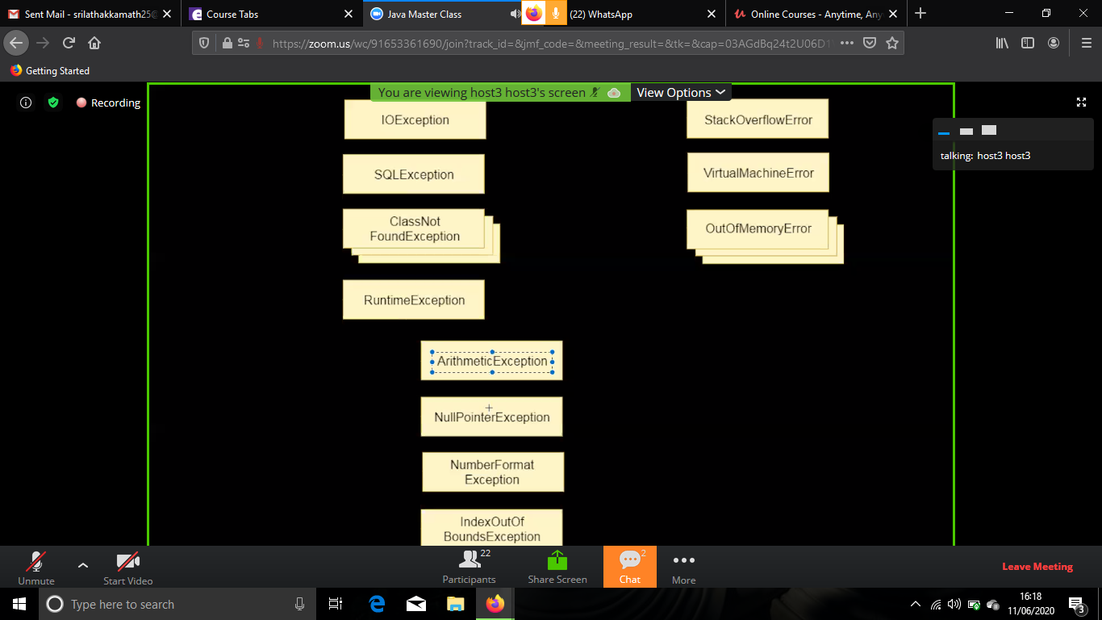

Coding examples: 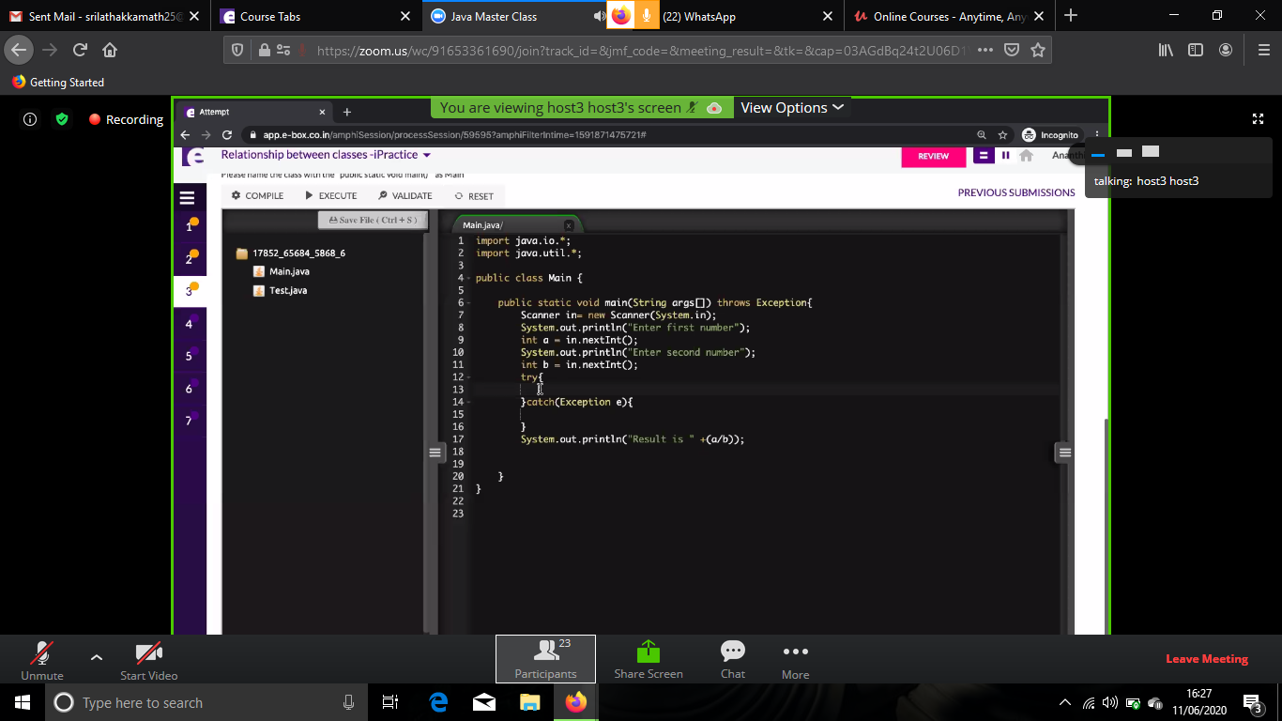

Online Coding Details:

1. Python Program to find the average of all Items in a Dictionary

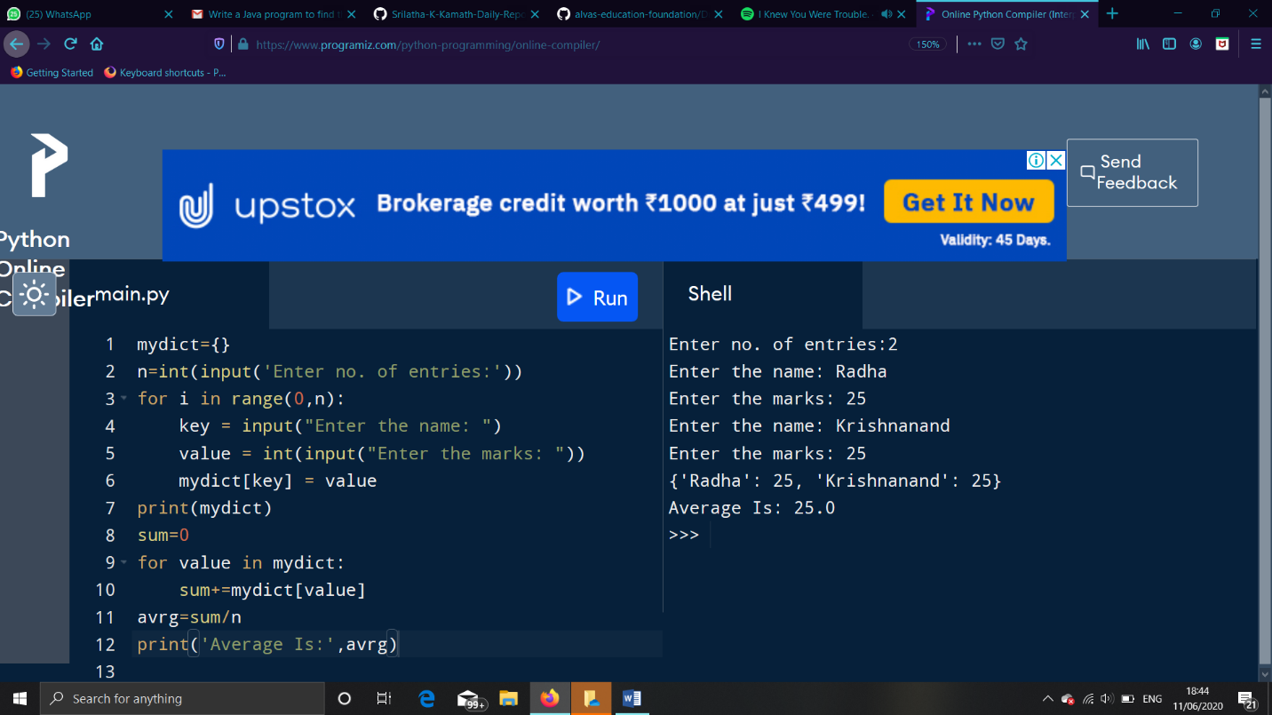

2. Java program to find the nodes which are at the maximum distance in a Binary Tree.

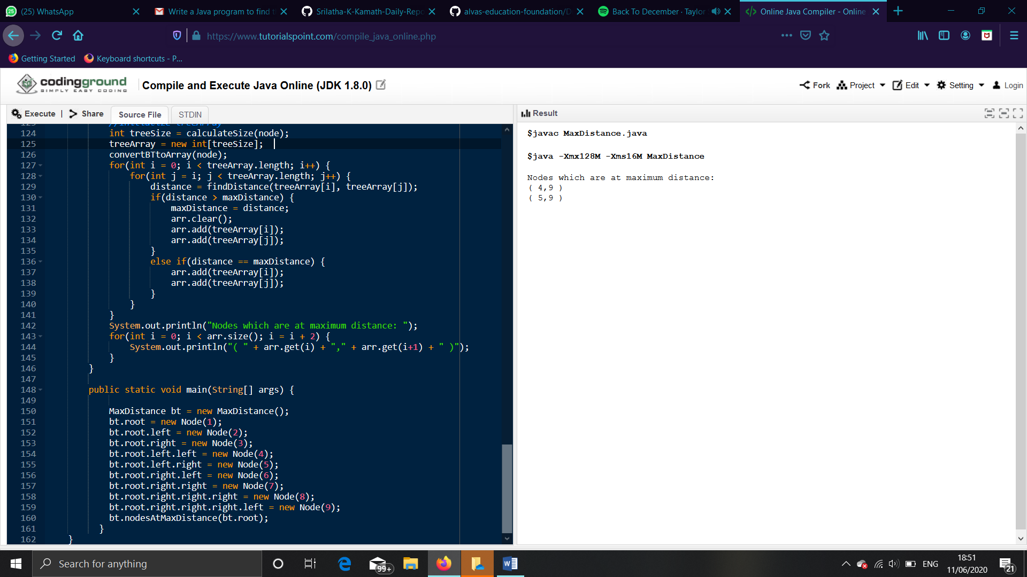

3. Python program that converts a string to all uppercase.